**Atılım University  
Computer Engineering  
CMPE225 Object-Oriented Programming**

**Spring, 2022-23  
Homework – II**

**Due Date: April 12, 2023, 23:59**

Write a C++ program to calculate scores of foreign language exams (Toefl, IELTS, Yökdil) using **polymorphism**. Your program should include the following:

* Abstract class **Exam** including the name and total score of the student and the date he/she took the exam. Write any required member functions.
* Class **TOEFL** derived from Exam which includes the number of correct answers for the reading, listening, speaking and writing sections of the exam as the data members. All sections have 30 questions each and the number of correct answers in the four sections are added together to calculate the total score. Write the necessary member functions.
* Class **IELTS** derived from Exam which includes the number of correct answers for the listening, reading, writing and speaking sections of the exam as well as their respective band scores as the data members. All sections have 40 questions each and the number of correct answers are converted to the IELTS nine-band scale using the following conversion table:

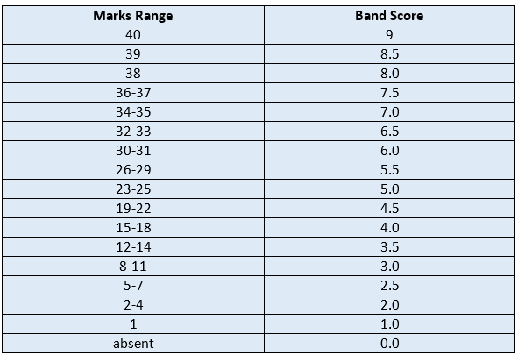

The total score is the average of the four section scores, rounded to the nearest whole or half band (e.g. 6.0 or 6.5). For example if a person received the following band scores in the 4 sections, his total score will be 6.0:

|  |  |  |  |  |  |
| --- | --- | --- | --- | --- | --- |
| **Listening** | **Reading** | **Writing** | **Speaking** | **Average** | **Total score** |
| 6.5 | 6.5 | 5.5 | 6.0 | 6.125 | 6.0 |

Write the necessary member functions.

* Class **Yokdil** derived from Exam which includes the number of correct answers out of 80 questions as the data member. Every correct answer adds 1.25 to the total score. Write the necessary member functions.

In your program read the information of 3 students as seen in the sample run, and output their names, date of exam, scores in each section (for Toefl & Yökdil) and total scores.

**Sample Run:**

Enter name of student: Ali

Enter date of exam: 25 11 2022

Enter T for TOEFL, I for IELTS or Y for Yokdil: T

Enter score for Reading: 22

Enter score for Listening: 22

Enter score for Speaking: 21

Enter score for for Writing: 18

Name: Ali Exam: TOEFL Date of exam:25/11/2022

Reading: 22 Listening: 22 Speaking: 21 Writing: 18

Total score: 83

Enter name of student: Zeynep

Enter date of exam: 18 3 2023

Enter T for TOEFL, I for IELTS or Y for Yokdil: I

Enter score for Reading: 32

Enter score for Listening: 33

Enter score for Speaking: 27

Enter score for for Writing: 30

Name: Zeynep Exam: IELTS Date of exam:18/3/2023

Reading: 6.5 Listening: 6.5 Speaking: 5.5 Writing: 6.0

Total score: 6.0

Enter name of student: Can

Enter date of exam: 4 5 2021

Enter T for TOEFL, I for IELTS or Y for Yokdil: Y

Enter number of correct answers: 70

Name: Can Exam: Yokdil Date of exam:4/5/2021

Total score: 87.5

**The grading of the homework will be based on:**

1. You have to upload your homework on time on Moodle.
2. Your file should be in the format that **yourname_surname_hw2.cpp**
3. Please **do not** upload **.exe** file, otherwise you will get zero.
4. Homework submitted via e-mail will be ignored.
5. This is not group work, so if anyone cheats or has a high similarity percentage (above 90%), will get zero.
6. If your code does not compile, your program will be evaluated over 80 pts.
7. Late submissions will not be graded.